C O N T A C T H O U R S
Registered nurses who complete the CNEP curriculum receive 36.5 continuing nursing education contact hours. Baptist Community Ministries Congregational Wellness is approved as a provider of nursing continuing professional development by Louisiana State Nurses Association Approver Unit, an accredited approver by the American Nurses Credentialing Center’s Commission on Accreditation. LSNA Provider No. 4002606

Congregational Health Promoters completing the CHPP training receive a Certificate of Completion which may be submitted to a licensing body for continuing education hours.

A F F I L I A T I O N S

“Foundations of Faith Community Nursing,” is the internationally recognized evidenced based curriculum for RN preparation in the sub-specialty of Faith Community Nursing (FCN). The content of the curriculum is written at the baccalaureate level. Maintenance and scheduled revisions /updates to the curriculum are the responsibility of The Westberg Institute. The Westberg Institute is a division of nursing for the Spiritual Care Association, 505 Eight Avenue, New York, NY 10018.

Congregational Health Promoter Program is based upon these published curricula: Community Health Advisor Network by Duke University, the Center for Sustainable Health Outreach and University of Southern Mississippi; Congregational Health Promoter Ministry Guide by Church Health Center, Memphis, Tennessee.

Church Nurse
Education Program
A basic preparation course
for registered nurses

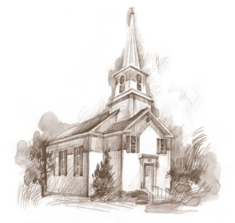
Congregational Health
Promoter Program

A basic preparation course
for all except RN’s
_________________________

Learn to start and grow a church
wellness ministry. Classes are open to
all denominations. No experience needed.
We embrace diversity and empower
members for active roles in the church.

Company Name
Company Address
City, State ZIP
Phone: 999-999-9999
Fax: 999-999-9999
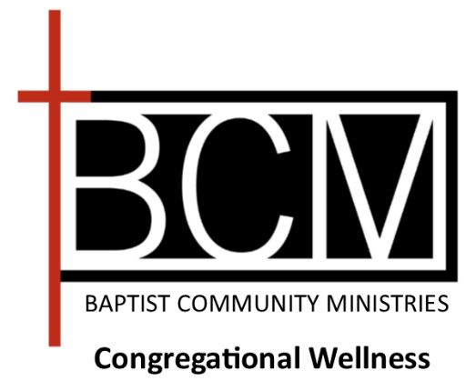

S T A F F

Our staff is comprised of multi-faith
professionals combining over 60 years
of expertise in faith community nursing
and congregational health promotion.
Faith Community Nurses | Congregational Health Promoters
Frances L. Hawkins MN, RN-BC  Vice President | Vanessa E. Burks MSW, Min. C.  Program Manager
Sharon Burel BSN, RN, MBA/HCM Nurse Manager | Lisa A. Collins BA, CHW, PHA Program Coordinator
Veronica Calliet  BSN, RN  Academic Consultant | Nia K. Davis M.Ed  Evaluation Consultant
Ann Nealy
MSN, RN, MBA
CNEP Consultant
Administrative Staff

Gretchen Dobbins
Administrative Assistant
Malea Myers
Data Analyst/Program Assistant

____________________________

For more information contact:
(504) 593-2339 sburel@bcm.org
(504) 593-2330 lcollins@bcm.org

2024 Classes
CNEP: Feb. 24, Mar. 9, 23, April 6,
CHPP: February 20, 27, March 5, 12, 19

CHURCH NURSE
EDUCATION PROGRAM
(CNEP)

CNEP is a hybrid/blended learning experience that prepares registered nurses to implement wellness ministries in their faith communities. The hybrid/blended delivery format includes both in class and on-line learning activities. The registered nurse facilitates integration of faith and health in the congregation through the application of an evidenced-based, professional volunteer model of health ministry. This emphasizes a wholistic, health promotion - disease prevention model incorporating the congregation’s values, beliefs, faith practices and missions.

O B J E C T I V E S

Upon completion of this program, the registered nurse should be able to:

- Assess the concepts of health, healing and wholeness in relation to the practice of church nursing.
- Construct a peer system of support that identifies health promotion resources in the church and the community.
- Assemble networks for continuing development of spirituality in health practices.
- Arrange health promotion activities for congregants across age span and socioeconomic groups.

CONGREGATIONAL HEALTH
PROMOTER PROGRAM
(CHPP)

CHPP prepares lay volunteers to implement church wellness ministries. Designed to improve and strengthen healthcare access, we educate any church members with a desire to serve. No prerequisites needed. CHP are volunteers who use their church, neighborhood and networks to provide referral services to congregants. When church or community health issues are encountered, they connect with local agencies to address wholistic health concerns.

O B J E C T I V E S

Upon completion of this program the ministry leader should be able to:

- Identify resources in the church and community
- Provide access to wellness and prevention activities.
- Provide referrals to community services.
- Build faith community teams.
- Promote healthy lifestyles.

C O U R S E C O N T E N T
- Health Promotion
- Assessment
- Accessing Community Resources
- Chronic Disease
- Nutrition & Exercise
- Spiritual Care & Prayer
- Spiritual Self-Care

S C H E D U L E S
CNEP and CHPP classes may be hybrid in 2024. Some classes may be on zoom. Graduation will be in person.
- Individual Tutorial for On-line Learning System
(Dates and times TBA)

- Orientation:
CNEP and CHPP February 6, 2024 6:00 am–8:30 pm

- CNEP is 4 Saturdays with bi-weekly on-line
course assignments.
February 24, March 9, 23, April 6, 2024
Time 8:00 am–4:30 pm

- CHPP is 5 Tuesday evenings 6:00 pm–9:00 pm
February 20, 27, March 5, 12, 19

- Commissioning service in person:
Monday, April 22, 2024

- Detailed schedule forwarded upon receipt
of registration.

F E E S

Waived for Spring 2024 classes
(for churches in Orleans, Jefferson, St. Tammany, St. Bernard and Plaquemines)
CNEP (out of area) $200.00
CHPP (out of area) $100.00

Classes may be cancelled or rescheduled due to low enrollment.

R E Q U I R E M E N T S

To enroll, students must have access to Wi-Fi and ZOOM on a laptop or tablet with a camera, chat, polling and evaluation features.

